Educational Attainment Unemployment, Gender, and Geography in the EU
EDTC Assignment 4
Deborah Nagler
New Jersey City University

Educational Attainment, Unemployment, Gender, and Geography in the EU
Introduction
Europe has a long history of shifting geo-political borders. In the 21st Century, it has been customary to divide Europe into four geographic regions: Northern, Western, Southern, and Eastern (UN Population Division, 2012). The establishment of the European Union (EU) in November 1993, however, has effectively redrawn the political and economic map of Europe.
Although the 28 member countries of the EU collaborate maintain political autonomy, they share a common currency, the Euro, and collaborate on a variety of economic and social issues. Over time, increasing economic convergence has been observed in EU countries (Geppert & Stephen, 2007), as the countries are reaching similar levels of wealth and development (Cambridge Dictionary, 2016).
This study examines the 2014 secondary school completion rates and unemployment rates for the EU population 20 to 24 years of age with the goal of highlighting indicators of convergence between the countries. The categorical variables of gender, geographic region, and national spending on education as compared to other EU countries will applied. The null hypotheses for this study are as follows:
- For secondary school completion rates, the averages for men and women will be equal: H_{O}=μ₁=μ₂.
- For the EU population 20 to 24 years of age, secondary school completion rates in 2014 will be not be affected by region or by the national expenditure for education: H_{O}=μ₁=μ₂=μ₃=μ_{4.}
- For the EU population 20 to 24 years of age, unemployment rates in 2014 will be not be affected by region or by the national expenditure for education: H_{O}=μ₁=μ₂=μ₃=μ_{4.}
Z-tests, chi-Square, cross tabulation, and ANOVA analysis were performed in order to test the validity of null hypotheses.
Data Collection
The EU statistical office, Eurostat, maintains statistics on a variety of topics related to economic and social development, including education. The statistics used in this study (Appendix A) were retrieved from Eurostat.com. Eurostat is the statistical office of the EU (Eurostat, 2016). While the Eurostat site provides information about the validity and reliability of its statistics, it did not provide the specific sampling methodologies used in the preparation of these datasets.
Summary of Statistics
Data Description Gender
Three datasets for secondary school completion by the EU population aged 20-24 (File T2 Population, 2015) in 2014 were analyzed: total population, men, and women, as shown in Table 1. With an n of 28 and no missing values, the mean of the percent of the total population completing secondary education is 84.26%. The median is 86.05% and the mode is 65.8%. The total population secondary school completion rate has a standard deviation of 7.46. The maximum score for total population secondary education completion rate is 96.3% and the minimum is 65.8%.
With an n of 28 and no missing values, the mean of the percent of males completing secondary education in 2014 is 81.9%. The median is 83.6% and the mode is 91.2%. Male’s completion rate has a standard deviation of 8.5. The maximum score for male’s completion rate is 95% and the minimum is 60.4%.
With an n of 28 and no missing values, the mean of the percent of women completing secondary school education in 2014 is 86.7%. The median is 88.8% and the mode is 71.7%. Women’s completion rate has a standard deviation of 6.8. The maximum score for women’s completion rate is 97.6% and the minimum is 71.4%.
The values for all completion rate datasets show a strong central tendency and are normally distributed, with very little influence from outliers, as shown in Chart 1. There is a slight negative skew in each instance, but skewness does not exceed 1.96 and therefore is not significant.
Table 1

Descriptive Statistics for Gender
 | N | Mean | Median | Mode | Standard  Deviation | Maximum | Minimum
Total Population | 28 | 84.2% | 86.1% | 65.8%ª | 7.47 | 96.3% | 65.8%
Men | 28 | 81.9% | 83.6% | 91.2% | 8.46 | 95% | 60.4%
Women | 28 | 86.9% | 88.8% | 71.4% ª | 6.85 | 97.6% | 71.4%
ªNote. Multiple modes exist for these variables. The smallest value is shown.

Chart 1. Total EU Population Ages 20-24 Years Completed Secondary School in 2014
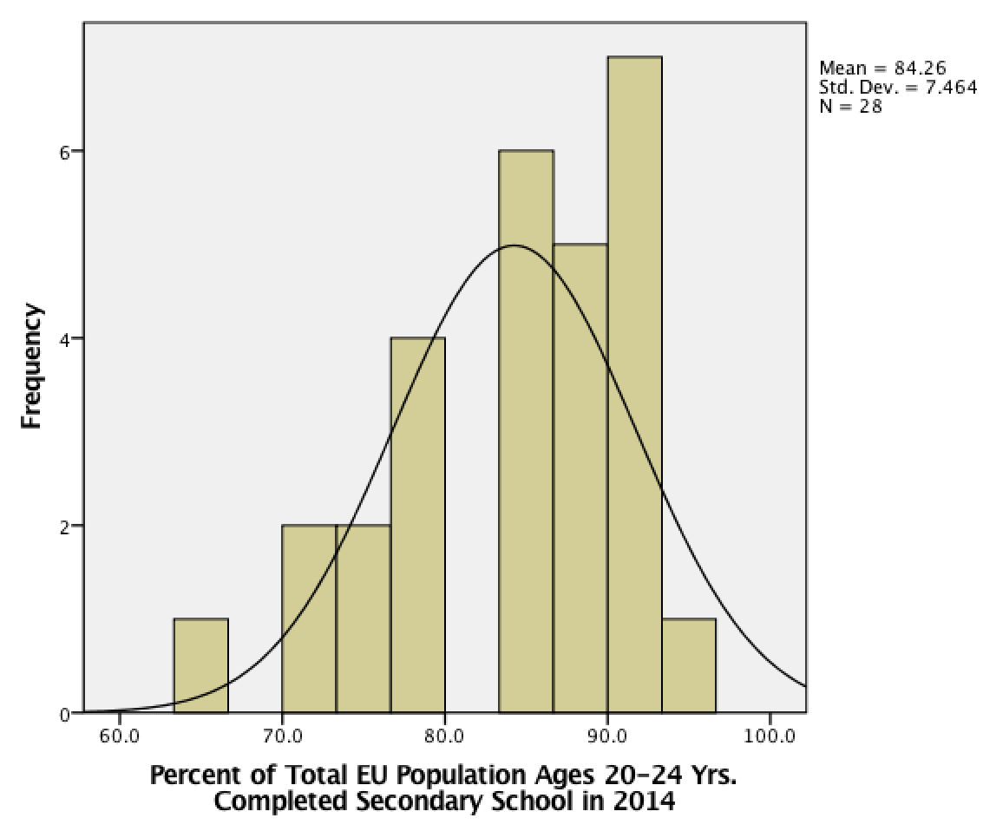
Gender Analysis
In order to determine whether the total population completion rates can be considered equally representative of both men and women, single sample z tests were performed. For male student completion rates, the results showed that the difference between the sample mean and the population mean was not significant and the effect size was medium (z= -1.7, p = .09, d = -.32). For female student completion rates, the results showed that the difference between the sample mean and the population mean was not significant and the effect size was medium (z = 1.8, p = .06, d= .35). Consequently the null hypothesis that for secondary school completion rates, the averages for men and women will be equal cannot be rejected. Consequently, the secondary school completion averages for total population were used without concern for gender differences in the ANOVA test that will be described in the next step of this analysis.

Data Description Unemployment
In its Framework for Education and Training 2000-2010 (EU Council, 2002), the EU member states affirmed its commitment to reduce unemployment by increasing secondary school graduation rates (Alegre & Benito, 2014). Due to this acknowledged link between education and employment, unemployment rates for EU youth, defined as under 25 years of age (Eurostat, 2016) were selected as the second quantitative statistic for this study.
The descriptive statistics for unemployment are shown in Table 2. With an n of 28 and no missing values, the mean of the percent of unemployed youth is 16.3%. The median is 15.2% and the mode is 8.1%. The percentage of unemployed youth has a standard deviation of 6.0. The maximum score for the percentage of unemployment is 29.5% and the minimum is 7.7%. The data for unemployment is normally distributed and has a strong central tendency, as shown in Chart 2. The data skews slightly right, but the values for skewness and kurtosis do not meet the criteria for significance.
Table 2

Descriptive Statistics for Unemployment
N | Mean | Median | Mode | Standard  Deviation | Maximum | Minimum
28 | 16.3% | 15.2% | 8.1%ª | 6.01 | 29.5% | 7.7%
ªNote. Multiple modes exist for these variables. The smallest value is shown.

Chart 2
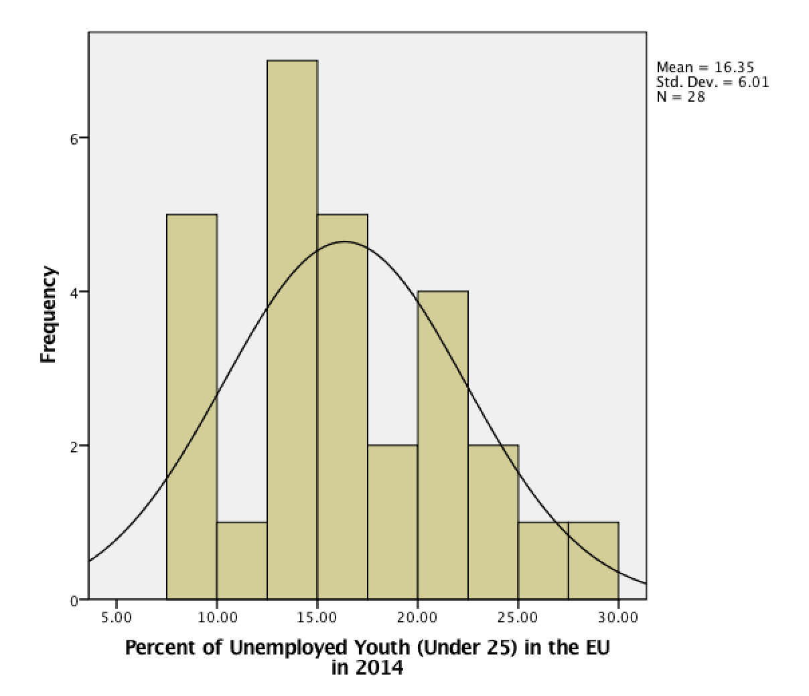
Percent of Unemployed Youth (Under 25) in the EU in 2014

This chart illustrates the distribution of the dataset.

Data Description National Expenditure on Education
Eurostat (2016) explains, “the proportion of financial resources devoted to education is one of the key choices made by national governments” (para. 2). It provides extensive data on this topic, which, in effect, are qualitative statistics. For the purposes of this study, one set of this data will be transformed into a categorical statistic. The data set for national educational expenditure will be described as it was originally presented, and then categorized as spending quartiles.
As shown in Table 3, with an n of 26 and 2 missing values, the mean of national expenditure on education in the EU in 2012 reported in millions of Euros is €25858. The median is €9128 and the mode is €467ª. National expenditure on education has a standard deviation of 3823.76. The maximum score for national expenditure is €129076 and the minimum is €467. These data are not normally distributed. These data skew to the right and produce a curve that is platykurtic, as can be seen in Chart 3. This is an indication that national expenditure on education among countries in the EU is not evenly distributed.
Table 3
Descriptive Statistics for National Expenditure on Education (Euros in Millions)
N | Missing | Mean | Median | Mode | Standard  Deviation | Maximum | Minimum
26 | 2 | €25858 | €9128 | €467ª | 38232.76 | €129076 | €467
ªNote. that multiple modes exist for these variables. The smallest value is shown.

Chart 3
National Expenditure on Education in the EU in 2012.
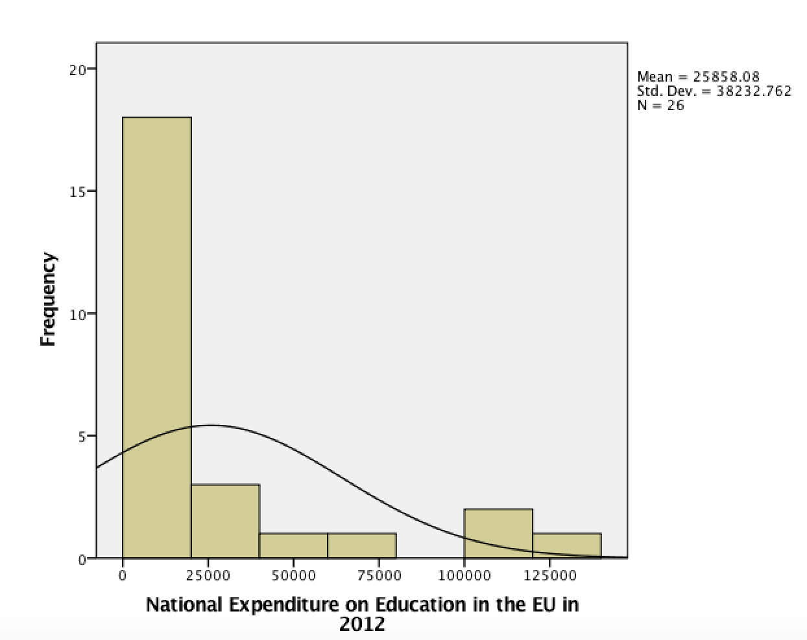

National Expenditure as a Categorical Variable
In order to transform the values for national expenditure into a categorical variable, the frequency was tabulated and the values were divided into four spending quartiles as indicated in Table 4 below.
Table 4
National Expenditure on Education Divided into Quartile Groups
Quartile | Valueª | Frequency ^{b} | Valid Percent
1 | €1667.25 | 10 | 38.5
2 | €9127.50 | 6 | 23.1
3 | 31412.75 | 4 | 15.4
4 | 31412.75 | 6 | 23.1
Total | --- | 26 | 100
Note. ª Value in millions of Euros
Note. ^{b} Two missing values

Regions as a Categorical Variable
The United Nations has divided the 28 member countries of the EU into four geographic regions (UN Population Division, 2012) (Appendix B). The frequencies of countries in each region and percentages of the whole for each region of Europe are displayed in Table 5 below.

Table 5
Geographic Regions of Europe by Frequency and Percent
Region | Frequency | Percent
1 - Northern | 6 | 21.4
2- Westernª | 8 | 28.6
3 - Southern | 8 | 28.6
4 - Eastern | 6 | 21.4
Totals | 28 | 100

Noteª. For the purposes of this study the United Kingdom has been included in Western Europe.

Analysis of Categorical Variables
A cross tabulation analysis of region and national education spending showed that 90% of the Q1 level of spending is evenly spread among countries in northern, southern, and eastern regions, as shown in Table 6 below. Eastern European countries account for 50% of Q2 level spending at 75%, and western countries likewise at the exceptionally high Q4 level, with 67%. A chi-square test of independence was performed to examine the relation between national education expenditure quartiles and region. The relation between these variables was significant, X² = (9, N = 26) = 17.53, p < .05. These data suggest that there are countries in every region that are spending at the lower quartile levels. At the same time, northern and eastern regions are not represented the Q4 level. Countries in the western region skew heavily toward higher spending on education. The southern region has strong representation at both the high and low ends of expenditure.
Table 6
Educational Expenditure and Region Variable Cross Tabulation
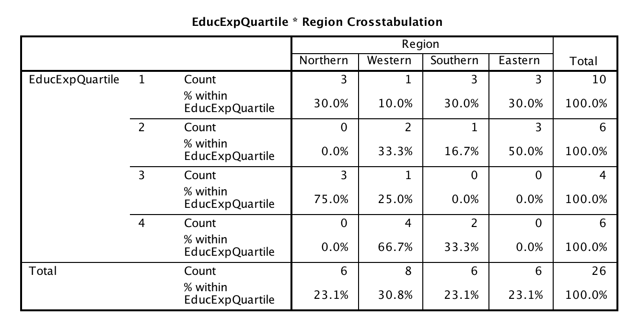

Analysis of Variance: Completion of Secondary School Education
A two-way between subjects ANOVA test was conducted to compare the effect of region and national educational spending on the completion rate for secondary school in the EU in 2014, as indicated in Table 7. (See Appendix C for Chart 7.) The significance level used was p=0.05. The test showed no significant effect from region on secondary school completion rates, F(3, 25) = 1.696, p = .211. The test showed no significant effect from the level of national educational spending on secondary school completion rates, F(3, 25) = 2.690, p = . 084. Finally, no statistical significance was found in the combination of the two factors, region and level of national educational spending, F(3, 25) = 16.147, p = .844. The null hypothesis which states that for the EU population 20 to 24 years of age, secondary school completion rates in 2014 will be not be affected by either region or by the national expenditure for education cannot be rejected. In other words, in 2014, the second school completion rate was the same for the EU population between 20 and 24 years of age regardless of region or the level of national expenditure on education.
Due to the absence of statistical significance for these variables, no post hoc tests were performed.
Table 7
ANOVA Results for Secondary School Completion as Affected by Region and Level of National Education Expenditure
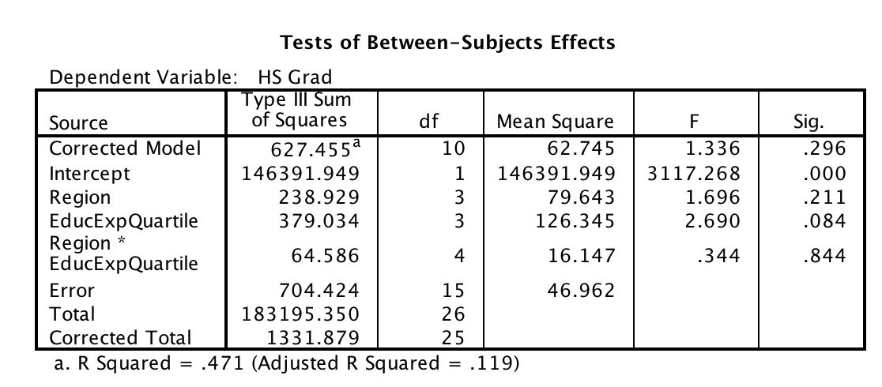
Analysis of Variance: Unemployment
A two-way between subjects ANOVA test was conducted to compare the effect of region and national educational spending on the unemployment rate for youth (under age 25) in the EU in 2014, as shown in Table 8. (See Appendix C for Chart 8.) The significance level used was p=0.05. The test showed a significant effect from region on unemployment rates, F(3, 25) = 12.219, p = .001. The test showed a significant effect from national educational spending on unemployment rates, F(3, 25) = 6.846, p = .004. As well, a statistical significance was found in the combination of the two factors, region and level of national educational spending, F(3, 25) = 6.223, p = .004.
Table 8
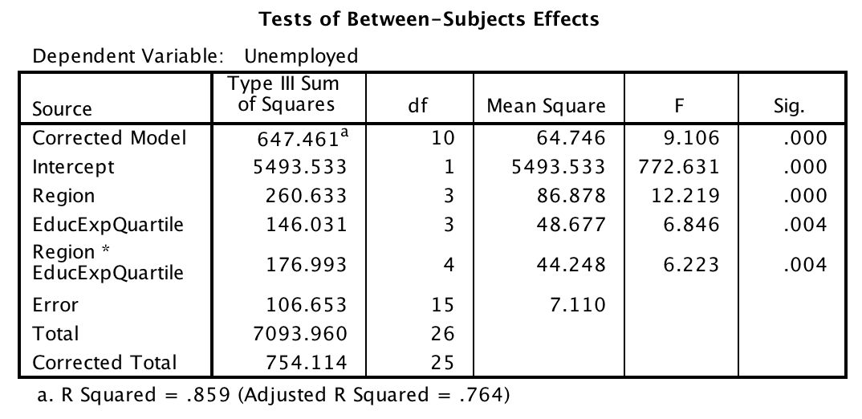
ANOVA Results for Unemployment of Youth as Affected by Region and Level of National Education Expenditure

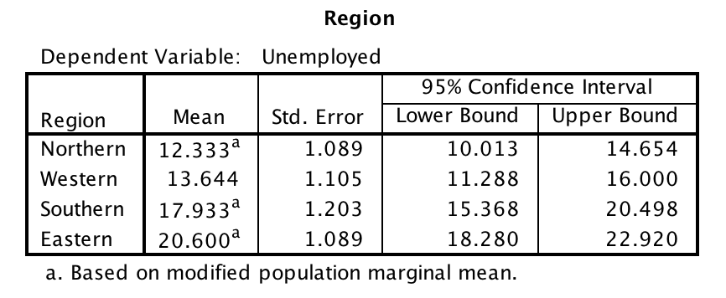

Post hoc analyses were conducted given the statistically significant ANOVA for these variables. As shown in Table 9, Tukey HSD tests were conducted on all possible pairwise contrasts. The following pairs of groups were found to be significantly different (p < .05): regions 1 (Northern Europe; M = 12.333, SD =5.762) and 3 (Southern Europe; M = 17.993, SD = 6.366), regions 1 (Northern Europe; M = 12.333, SD =5.762) and 4 (Eastern Europe; M =2.6, SD = 10), regions 2 (Western Europe; M =13.644, SD = 5.847) and 3 (Southern Europe; M = 17.993, SD = 6.366), and regions 2 (Western Europe; M =13.644, SD = 5.847) and 4 (Eastern Europe; M =2.6, SD = 10). In other words, upon closer examination, the unemployment rates in Southern and Eastern Europe were the highest and showed the most effect from location (region) and level of national spending on education.
Table 9
Pairwise Comparisons of Groups within the ANOVA
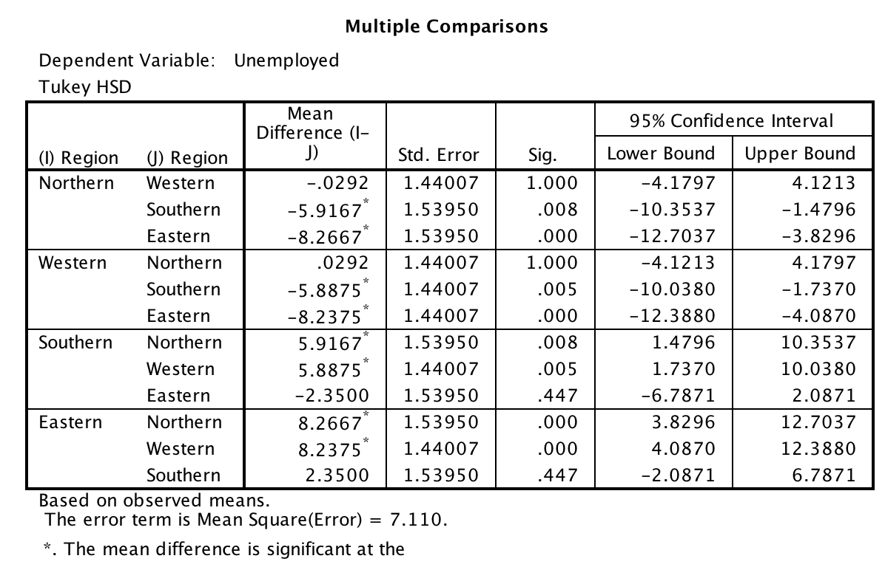
Conclusion
In this study of educational attainment in the EU examined Eurostat statistics for secondary school completion by the population ages 20 to 24 years and unemployment rates for a similar population. These quantitative statistics were evaluated in light of available information for three categorical variables: gender, geographic region, and quartile of national expenditure on education.
With respect to gender, the data did not show a significant difference between men and women. This outcome encouraged the researcher to use the mean of the population for secondary school completion as a statistic reflective of both men and women. Abrantes and Abrantes (2014 assertion that the “impact of gender on… educational attainment…in Europe is far from uniform” calls into question the validity of this choice (p. 377). It may be that increasing equality in educational achievement is the case for the EU. The EU is certainly striving for this goal (Zellmer, 2015). At the same time, this hypothesis would benefit from additional statistical data and review.
The results of the ANOVA analysis showed no correlation between the data for secondary school completion and the affects of geographic region and/or national expenditure on education. This begs for review of the categorical statistics. The topic of regions in Europe and the European Union is not as simple as lines drawn on the globe. Jones (2012) suggests that “notions of … region that refer to bounded spatial units – the so-called territorial viewpoint – are being challenged, and in some instances usurped, by concepts which draw attention to interspatial relations, flows and networks – the so-called relational viewpoint” (p. 263). In effect, the social, economic, and cultural boundaries of the countries of the EU are changing. Jones (2012) continues by saying that the pace of this change differs from place to place. Therefore, geographic region may not be the best category to use when examining educational convergence. In the very least, it demands support from other variables that capture the dynamic political, social, and economic changes in the EU.
Finally, the analysis of ANOVA for unemployment among youth in a comparison of geographic region and national education expenditure did show strong correlations. Southern and Eastern Europe showed the highest rates of unemployment as compared to Northern and Western Europe, where national expenditure on education was also considerably higher. This result certainly appears to support the accepted wisdom that education and employment are compatible. However, lessons learned about the complexity of the EU and the influence of the dynamic forces of history, geo-politics, economics, and society on the outcomes of seemingly simple statistical models demand due consideration. The results of this study suggest that there might be a correlation between investment in education and lower unemployment for youth in the EU. This conclusion, as well, would benefit from additional research and substantiation.

References
Abrantes, P., & Abrantes, M. (2014). Gendering social mobility: a comparative perspective on the nexus of education and class across Europe. Gender & Education, 26(4), 377-396. doi:10.1080/09540253.2014.916399
Alegre, M. À., & Benito, R. (2014). Youth Education Attainment and Participation in Europe: the role of contextual factors and the scope of education policy. European Journal Of Education, 49(1), 127-143. doi:10.1111/ejed.12045
Economic convergence [Def 1]. (2016). In Cambridge Dictionaries Online. Retrieved from http://dictionary.cambridge.org/us/dictionary/english/economic- convergence
Eurostat. (2016). Educational expenditure statistics. Eurostat Statistics Explained. Retrieved from http://ec.europa.eu/eurostat/statistics-explained/index.php/
Educational_expenditure_statistics
Geppert, K., & Stephan, A. (2008). Regional disparities in the European Union: Convergence and agglomeration. Papers In Regional Science, 87(2), 193-217. doi:10.1111/j.1435-5957.2007.00161.x
Glossary: European Union. (2016). Eurostat Statistics Explained. Retrieved from http://ec.europa.eu/eurostat/statistics-explained/index.php/Glossary:European_
Union_%28EU%29
Jonas, A. E. (2012). Region and place: Regionalism in question. Progress In Human Geography, 36(2), 263-272. doi:10.1177/0309132510394118
Main Indicators for Public Expenditure [Table]. (2016). File: Main indicators for public expenditure on education excluding early childhood educational development. Eurostat Statistics Explained. Retrieved from ttp://ec.europa.eu/eurostat/statistics- explained/index.php/File:Main_indicators_for_public_expenditure_on_education _%28excluding_early_childhood_educational_development%29,_2012_
ET15.png
Population aged 20–24. (2015). File:T2 Population aged 20–24 having completed at least upper secondary education (ISCED 3), by sex and country, 2014 (%).png. Eurostat Statistics Explained. Retrieved from http://ec.europa.eu/eurostat/statistics-explained/index.php/File:T2_
Population_aged_20%E2%80%9324_having_completed_at_least_upper_second ary_education_%28ISCED_3%29,_by_sex_and_country,_2014_%28%25%29.pn g#file
Rodríguez-Pose, A., & Tselios, V. (2009). Education and income equality in the regions of the European Union. Journal Of Regional Science, 49(3), 411-437. doi:10.1111/j.1467- 9787.2008.00602.x
UN Population Division. (2012). Classification of country by major area and region of the world. World Population Prospects: 2012 Revision. Retrieved from http://www.unep.org/tunza/tunzachildren/downloads/country-Classification.pdf
Young people neither in employment. (2016). Young people neither in employment nor in education and training by sex and age (NEET rates) [edat_lfse_20]. Eurostat Statistics Explained. Retrieved from http://appsso.eurostat.ec.europa.eu/ nui/show.do
Youth Unemployment [Table].(2015). File:Table 1 Youth unemployment, 2014Q4 (%).png. Eurostat Statistics Explained. Retrieved from http://ec.europa.eu/eurostat/statistics-explained/index.php/ File:Table_1_Youth_unemployment,_2014Q4_%28%25%29.png
Zellmer, K. (2015). Forum on the future of gender equality in the European Union.
(PDF). European Commission. Retrieved from http://ec.europa.eu/justice/events/
future-of-gender-equality-015/files/report_forum_gender_equality_en.pdf

Appendix A
European Union Dataset
 | Country | Region | Tot Grad | Men  Grad | Women  Grad | Unempl | Natl  EdEx | EdEx  Quart.
1 | Croatia | 3 | 96.3 | 95.0 | 97.6 | 22.20
2 | Ireland | 2 | 92.6 | 91.2 | 94.0 | 18.90 | 10106 | 1
3 | France | 2 | 87.9 | 91.2 | 89.4 | 15.20 | 115479 | 4
4 | Slovakia | 4 | 90.9 | 90.6 | 91.3 | 21.40 | 2169 | 1
5 | Lithuania | 1 | 91.4 | 90.0 | 92.8 | 13.50 | 1590 | 1
6 | Czech Rep | 4 | 90.7 | 89.9 | 91.4 | 24.70 | 6616 | 1
7 | Austria | 2 | 89.6 | 89.5 | 89.6 | 9.90 | 17084 | 2
8 | Poland | 4 | 90.4 | 87.4 | 93.6 | 15.80 | 18736 | 2
9 | Slovenia | 3 | 90.2 | 87.3 | 93.3 | 13.60 | 1922 | 1
10 | Cyprus | 3 | 92.4 | 87.1 | 97.4 | 19.50 | 1181 | 1
11 | Bulgaria | 4 | 85.8 | 85.8 | 85.8 | 24.80 | 1469 | 1
12 | Sweden | 1 | 86.9 | 85.2 | 88.7 | 7.70 | 30108 | 3
13 | Greece | 3 | 88.4 | 85.1 | 91.7 | 29.50
14 | Finland | 1 | 86.3 | 83.9 | 88.9 | 12.90 | 13696 | 3
15 | Hungary | 4 | 85.3 | 83.3 | 87.3 | 16.90 | 3942 | 2
16 | United Kingdom | 2 | 84.1 | 82.7 | 85.5 | 13.20 | 115951 | 4
17 | Latvia | 1 | 86.7 | 82.5 | 91.0 | 16.60 | 811 | 1
18 | Belgium | 2 | 84.4 | 81.0 | 87.8 | 14.80 | 24817 | 3
19 | Romania | 4 | 79.7 | 78.4 | 81.1 | 20.00 | 3476 | 2
20 | Estonia | 1 | 83.6 | 78.2 | 89.2 | 15.20 | 842 | 1
21 | Italy | 3 | 79.9 | 76.6 | 83.2 | 27.40 | 65884 | 4
22 | Germany | 2 | 77.1 | 75.4 | 79.0 | 10.40 | 129076 | 4
23 | Netherlands | 2 | 79.0 | 74.7 | 83.4 | 8.10 | 35327 | 4
24 | Malta | 3 | 75.5 | 72.4 | 78.9 | 13.10 | 467 | 1
25 | Luxembourg | 2 | 73.7 | 72.1 | 75.3 | 8.40 | 1693 | 2
26 | Denmark | 1 | 72.5 | 68.2 | 76.9 | 8.10 | 17029 | 3
27 | Portugal | 3 | 72.1 | 67.4 | 76.8 | 13.50 | 8149 | 2
28 | Spain | 3 | 65.8 | 60.4 | 71.4 | 22.40 | 44690 | 4

Appendix B
Regions of Europe
Northern Europe | Western Europe | Southern Europe | Eastern Europe
Denmark | Austria | Croatia | Bulgaria
Estonia | Belgium | Cyprus | Czech Republic
Finland | France | Greece | Hungary
Latvia | Germany | Italy | Poland
Lithuania | Ireland | Malta | Romania
Sweden | Luxembourg | Portugal | Slovakia
 | Netherlands | Slovenia
 | United Kingdom | Spain

Appendix C
Charts for ANOVA Analyses
Chart 7
Estimated Marginal Means for Secondary School Completion by Region and Educational Expenditure Quartile
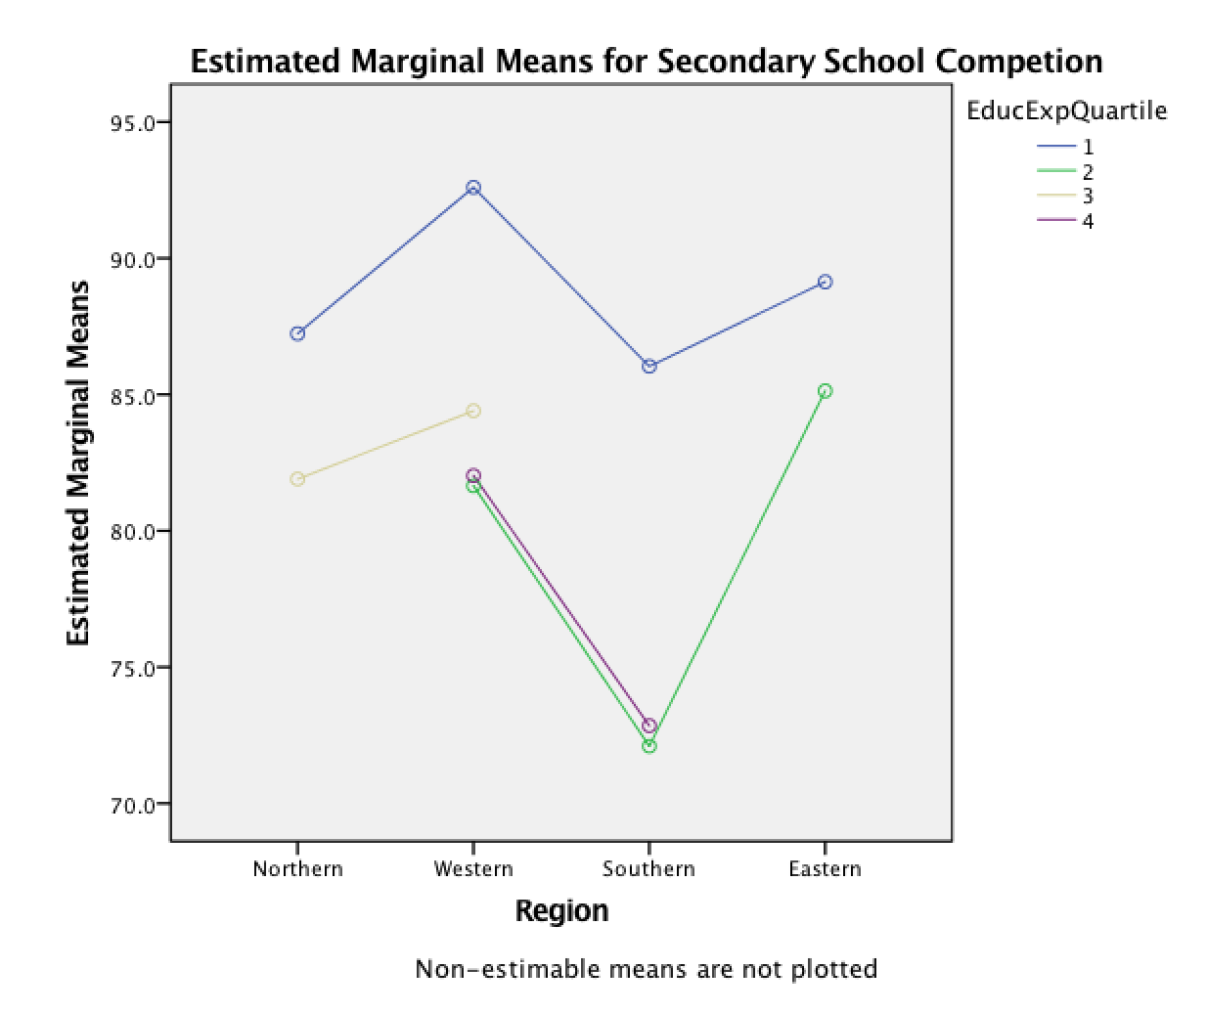

Chart 8
Estimated Marginal Means for Unemployment by Region and Educational Expenditure Quartile
